1. Sources Code

perkenalan.php🡪controller

2. URL

<http://localhost/pustaka_ajeng/index.php/perkenalan>

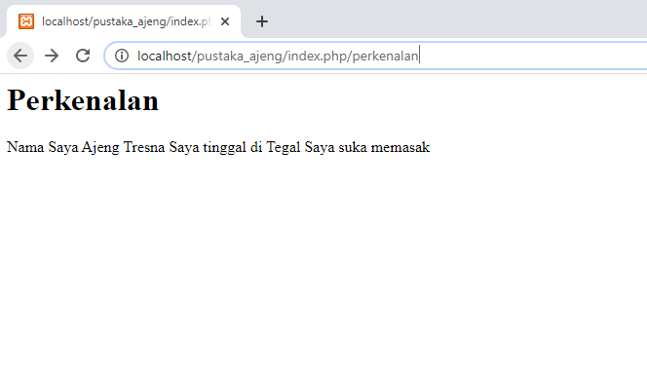3. Capture Output Program